Exp.No:23
23. Perform Sharpening of Image using unsharp masking.

Aim:
To sharpen an image using the Unsharp Masking technique using OpenCV.
Formula:
Sharpened Image = Original Image + (Original Image − Blurred Image)
Procedure:
- Start the program.
- Import OpenCV.
- Read the input image Beautiful Flowers.jpg.
- Create a blurred version of the image using Gaussian Blur.
- Subtract the blurred image from the original image to obtain the mask.
- Add the mask to the original image.
- Display the original, blurred, and sharpened images.
- Save the sharpened image.
- Stop the program.
Program:
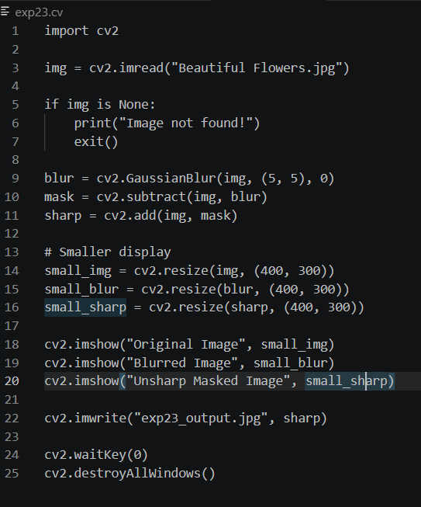

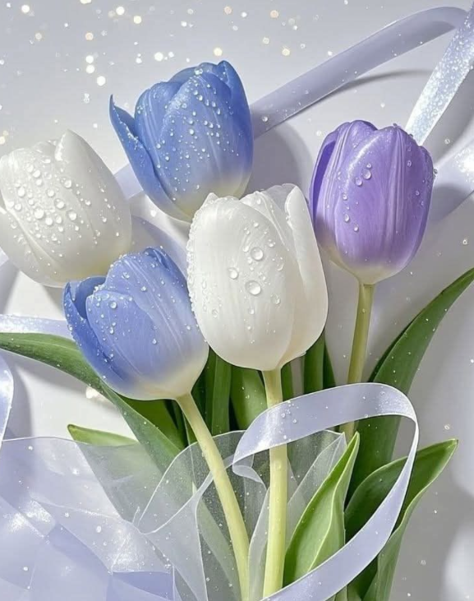
Input:

Output:
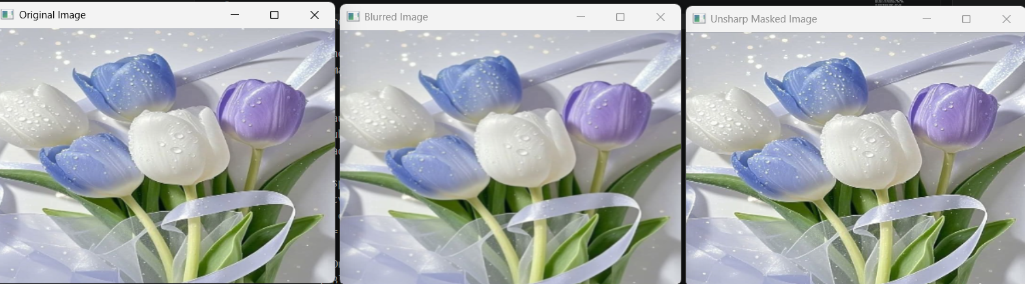

Result:
The image was successfully sharpened using the Unsharp Masking technique, and the sharpened image was displayed and saved successfully.

